|  |
| --- |
| Hello,  Now that you have had time to use your new TWFISH CAM, we would like you to fill out our survey. The results from this survey will help us serve you better, by giving you the high-quality products that you deserve**.**  Overall, how satisfied are you with TWFISH CAM?  Not Satisfied  Somewhat satisfied  Satisfied  A little satisfied  Very satisfied  **r** |
| How was the setup of TWFISH CAM to the mobile app?  Very Easy  Somewhat easy  Easy  Hard  Extremely Hard | |

|  |
| --- |
| From a scale of one to ten, one being not at all and ten being completely agree how would you rate the following statements.  I had no problem setting up and using TWFISHCAM with my fishing pole.  1 2 3 4 5 6 7 8 9 10  The TWFISH CAM is worth the money spent.  1 2 3 4 5 6 7 8 9 10  I would recommend TWFISHCAM to a friend!  1 2 3 4 5 6 7 8 9 10 |

|  |
| --- |
| Which picture is most like your recordings from the TWFISH CAM?    A B C D  Please note; If your recordings are not like picture A, please get ahold of our tech support. |

Any additional comments? Or anyway we could improve our product to better fit your needs?

|  |
| --- |
|  |

Thank you for using your valuable time for our survey. We hope you have many happy hours of use from TWFISHCAM. Remember if you ever have any questions or concerns feel free to reach out to us.

Happy Fishing!!

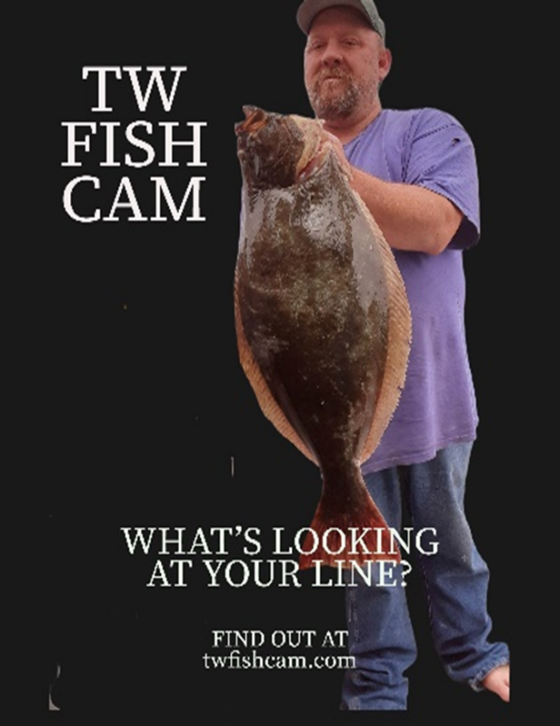

TWFISHCAM

twfishcam.com

[twfishcam@gmail.com](mailto:twfishcam@gmail.com)

8happyfish

842-779-3474