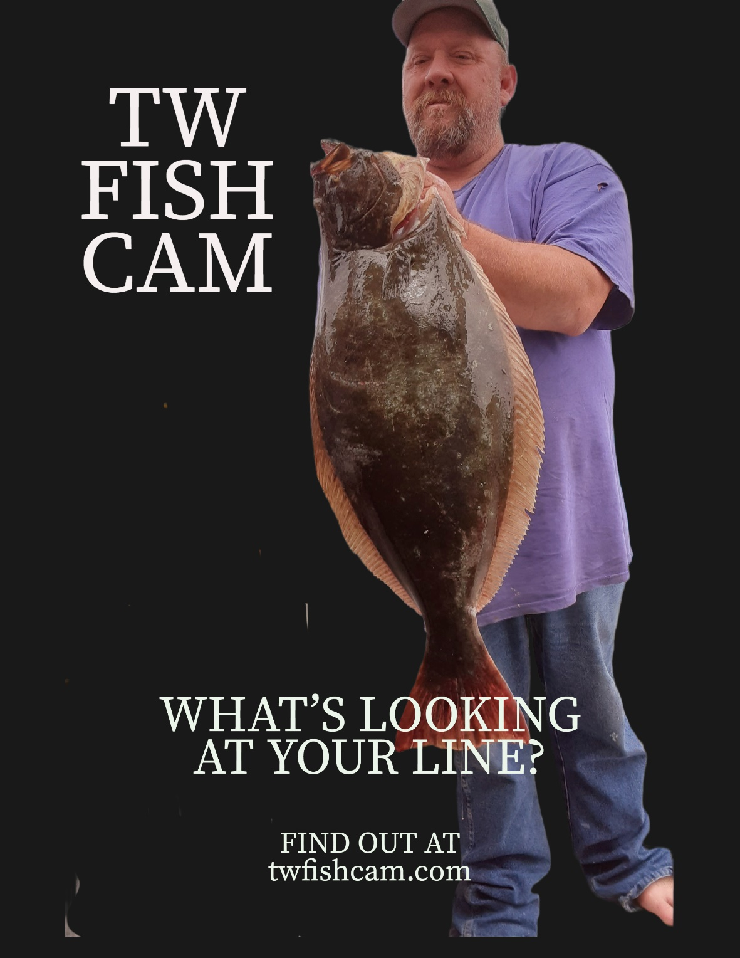

Underwater Fishing Camera

Owner’s Manual

TABLE OF CONTENTS

Introduction 2

Tools Needed 3

Safety Warnings 3

Charging the TW viewer 4

Procedures 4

Troubleshooting 5

Contact Us 5

Hello and welcome to the TW FISH CAM Family!

Thank you for your purchase, we hope you have countless hours of fun using this unit. TW FISH CAM is a wireless underwater camera you use just like a dodger on your fishing line and works with a mobile app. on your phone or on the TW viewer. The Dodger attaches in-line between your 50 lb. test line and leader line. Please read this instruction manual closely to get the most out of your TW FISH CAM.

If you have any problems or concerns, please feel free to reach out to us.

Tools needed

A fishing Pole, a Type C transmitter (included), a TW viewer the fits on your fishing pole or, a smart phone with app installed with either way you can capture action-packed footage, gain insight into the underwater fishing experience, and review and edit awesome video content that can be saved or shared with friends.

|  |
| --- |
|  |

|  |
| --- |
|  |

Safety Warnings

This unit can operate in water up to 500 ft, for one hour. If used in deeper water the performance will be of inferior quality and the unit could be damaged from water pressure. Please provide the care and maintenance guidelines described in this document, they should be strictly followed. If used in salt water, rinse in clean freshwater, such as tap water. Any malfunction caused by customer misuse, or mishandling will not be covered by the warranty. Do not get Type C Transmitter wet it is connected to TW Dodger digitally. also use care not to get TW viewer wet it could malfunction.

Charging the Battery

(Only for TW viewer)

When this unit is purchased, the battery is not charged. Charge the battery fully before using this unit for the first time. This unit has a built-in rechargeable lithium-ion battery. The indicator light on the back of the unit will turn red to indicate that it is charging. Once the unit is completely charged the charging light will turn off. Once charging is complete, disconnect the Type C cable from the TW viewer.

Procedures

First using a secure knot tie the TW FISH CAM Dodger to your line using 50-pound test (recommended)

Next tie another five inches of 50 lb. test to the bottom and tie your leader to the TW FISH CAM Dodger.

Then plug the Type C transmitter into the TW viewer or into a cell phone that has our app installed.

You can now cast, drop your line, or use it for trolling and enjoy many hours of fun seeing where the fish are or the condition of the landscape.

Troubleshooting

Problem Check

|  |  |
| --- | --- |
| TW viewer not working | Make sure the unit is fully charged, the unit is not on charging mode and the cable is completely inserted |
| TW viewer not showing pictures | Make sure the cable is completely inserted to the viewer and there is no damage to Dodger. |
| Dodger is damaged | If Dodger is damaged through no fault of the customer, please return it to us and we will replace it. |
| Dodger is damaged – customers fault | We will not replace. |

Contact us

Online at TWFISHCAM.com

By email [twfishcam@gmail.com](mailto:twfishcam@gmail.com)

Phone 1-8happyfish/ 1-842-779-3474

HAPPY FISHING!